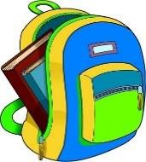4th Grade Supply List

***Welcome to fourth grade***! This will be an exciting, adventurous year of many exploratory opportunities: 1:1(1 laptop: 1 Student) technology classrooms, hands-on science and much more! Please provide the following school supplies and bring them with you on your first day of

FOURTH grade:

# Supplies TO bring to school…

* *Clearly labeled refillable water bottle with tight, closing lid (no straws, please)*
* Headphones with name clearly labeled
* *A classroom donation of $40*
  + *If your last child’s last name is A-S, please bring a box of tissues*
  + *If your last child’s last name is T-Z, please bring in Clorox or Lysol Wipes*
* *Optional: if your child would like to bring in their own pencils, please feel free to do so.*

***Fourth Grade will be purchasing school supplies for your child from the class fee. This fee will help to provide individual***

***supplies for your child’s successful and safe Fourth Grade year.***

***Please be advised that any additional items that come from home will be returned. Thank you for your patience, flexibility,***

***and support!***

Your class fee will go to the following items:

Pencils, rulers, erasers, whiteboard dry erase markers, scissors, coloring utensils, class incentives, craft supplies, individual

curriculum supplies and subscriptions.

(If you are unable to pay the class fee in one lump sum, please contact your teacher to make arrangements.)

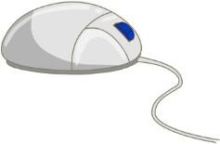Please make checks payable to

# Spanish Springs Elementary School.

**Thank you so much!**

**We are looking forward to an exciting year in 4th Grade!**